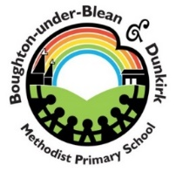 | School Uniform Order Form
We hold a limited stock at school. Items may be cheaper online at www.mapac.com. Delivery is free for orders over £50.

Sweatshirts  Cardigan  Red or white polo  shirts  Book Bag | £8.50  £10.50  £7.50  £7.50 |  | School hoodie  PE Kit (t-shirt, shorts & bag)  PE t-shirt  PE Shorts  PE Bag | £12.00  £10.00  £4.00  £4.00  £2.00

At Mapac online you can order the above items plus school rucksacks (KS2), fleeces, coats, school skirts, trousers etc.

Sizes
Age 3/4 Age 5/6 Age 7/8 Age 9/10
Age 11/12 Age 13 Small Adult Medium Adult
Garment | Size | Colour | Quantity | Item Price | Total

You will be notified when the uniform has arrived at school. Please pay online via Schoolcoms if buying direct from the school.
Child’s Name…………………………………………….. Year …………………

